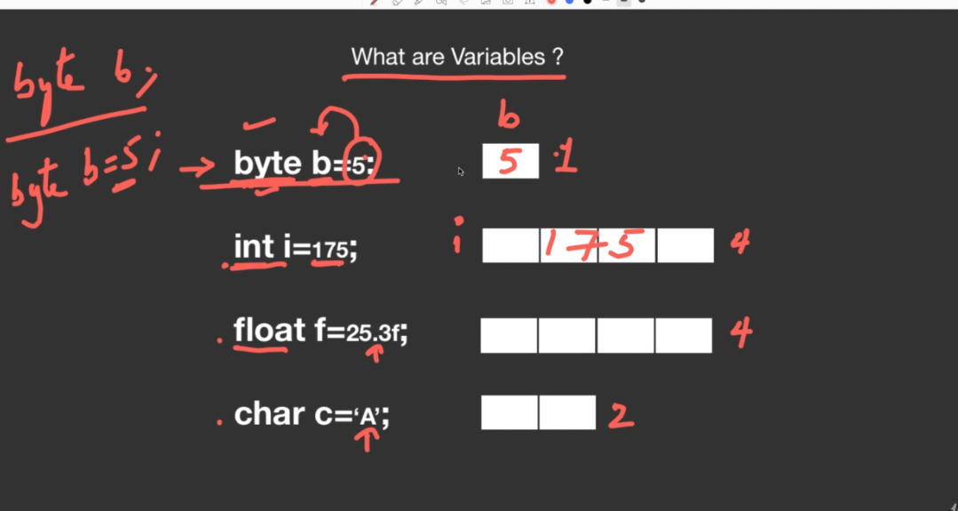
☕ Java Variables — Training Notes

🔷 What is a Variable?
A variable is a name given to a piece of data stored in memory.
Think of it like a labelled box — the label is the variable name, and whatever is inside the box is the value.
Two key rules about variables:
- A variable must have a data type
- A variable must be declared before use

🔷 Declaration vs Initialization
Declaration — Creating the variable (box)
java
byte b;
- Memory is reserved for b
- No value is stored yet
- Has a default value of 0 (for numeric types)
- ⚠️ You cannot use a variable before initializing it — Java will throw a compile error
Initialization — Storing a value in the variable
java
byte b = 5;
- Memory is reserved and the value 5 is stored in b
Combined Example
java
int i = 175;
// ↑ Declaration ↑ Initialization

🔷 How to Choose the Right Data Type
Ask yourself: What kind of data am I storing?
Data | Choose
Small whole number (fits in -128 to 127) | byte
Medium whole number | short
General whole number | int ✅ most common
Very large whole number | long
Decimal number (less precise) | float
Decimal number (more precise) | double
A single alphabet/character | char
True or False | boolean

🔷 Memory Allocation
When you declare a variable and run the program, Java allocates memory for it at runtime:
byte b = 5; → occupies 1 byte in memory
int i = 175; → occupies 4 bytes in memory
float f = 25.3; → occupies 4 bytes in memory
char c = 'A'; → occupies 2 bytes in memory
📌 The amount of memory depends on the data type, not the value stored.

🔷 Can You Change a Variable's Value?
Yes! You can reassign a variable anytime after declaration:
java
byte b = 5;
System.out.println(b); // prints 5

b = 25;
System.out.println(b); // prints 25

🔷 What Happens When You Exceed the Range?
If you try to store a value beyond the range of a data type, Java throws a compile-time error:
java
byte b = 130; // ❌ ERROR: byte max is 127
// Error: incompatible types: possible lossy conversion from int to byte

byte b = 127; // ✅ OK — this is the maximum value for byte
💡 If your value is larger than byte can hold, simply upgrade to short, then int, then long.

🔷 Step-by-Step: Write & Run the Program
Step 1 — Create Variables.java
java
public class Variables {
public static void main(String[] args) {

byte b = 5; // 1 byte → small whole number
short s = 300; // 2 bytes → medium whole number
int i = 100; // 4 bytes → general whole number
float f = 25.3f; // 4 bytes → decimal (note the 'f' suffix!)
char c = 'A'; // 2 bytes → single character

System.out.println(b); // 5
System.out.println(s); // 300
System.out.println(i); // 100
System.out.println(f); // 25.3
System.out.println(c); // A
}
}
Step 2 — Compile
bash
javac Variables.java
Step 3 — Run
bash
java Variables
Expected Output
5
300
100
25.3
A

🔷 Common Beginner Mistakes to Avoid
Mistake | What Happens | Fix
Using a variable before initializing | Compile error: "variable might not have been initialized" | Always assign a value before use
Storing a value beyond data type range | Compile error: "possible lossy conversion" | Choose a larger data type
Writing float f = 25.3; (no f suffix) | Compile error — Java treats 25.3 as double by default | Write 25.3f for float values
Writing char c = A; (no quotes) | Compile error | Always use single quotes: 'A'

🔷 Quick Practice Tasks
Try these on your own:
java
// 1. Declare a long variable and store a 10-digit number
long population = 1400000000L; // note the 'L' suffix

// 2. Declare a double and store a precise decimal
double pi = 3.14159265358979;

// 3. Declare a boolean
boolean isEligible = true;

// 4. Try storing 128 in a byte — observe the error
byte b = 128; // ❌ intentional error to learn from

💡 Interview Spotlight
Q1. What is the difference between declaration and initialization of a variable in Java?
Declaration means creating a variable with a data type (byte b;). Initialization means assigning a value to it (b = 5;). Java does not allow you to use a variable that has been declared but not initialized — it gives a compile-time error.
Q2. What happens if you try to store a value beyond the range of a data type?
Java throws a compile-time error: "incompatible types: possible lossy conversion". For example, storing 130 in a byte (max 127) will fail. You must choose a data type whose range can accommodate your value.
Q3. Why do you write 25.3f instead of just 25.3 for a float variable?
In Java, any decimal literal like 25.3 is treated as double by default. To explicitly tell the compiler it is a float, you must append the f suffix — 25.3f. Without it, you get a compile-time error: "possible lossy conversion from double to float".

☕ Java Variable Naming Rules — Training Notes

🔷 Why Do Naming Rules Matter?
In large projects with hundreds of variables, naming becomes critical. A wrong name can cause compile errors or confuse other developers. Java has strict rules (must follow) and guidelines (best practices).

🔷 Rule 1 — Variable Names Are Case Sensitive
Java treats uppercase and lowercase letters as completely different characters.
java
int amount = 10; // variable 1
int Amount = 20; // variable 2 — completely different!
int amounT = 30; // variable 3 — different again!
✅ All three are separate variables — even one letter's case change makes it a new variable.
❌ You cannot declare two variables with the exact same name in the same method:
java
int x = 5;
float x = 3.2f; // ❌ ERROR — 'x' already declared

🔷 Rule 2 — Allowed Characters in Variable Names
A variable name can contain:
Allowed | Examples
Alphabets (a–z, A–Z) | amount, Name
Numbers (0–9) | room1, cabin151
Underscore _ | roll_number
Dollar sign $ | total$amount
❌ Spaces and all other special characters are NOT allowed:
java
int roll number; // ❌ ERROR — space not allowed
int roll@number; // ❌ ERROR — @ not allowed
int roll#number; // ❌ ERROR — # not allowed

🔷 Rule 3 — Variable Name Must NOT Start With a Number
The first character must be a letter, underscore, or dollar sign.
java
int x1 = 5; // ✅ starts with alphabet
int _x = 5; // ✅ starts with underscore
int $x = 5; // ✅ starts with dollar sign

int 1x = 5; // ❌ ERROR — starts with number
int 1room = 5; // ❌ ERROR — starts with number

🔷 Rule 4 — Do NOT Use Java Keywords as Variable Names
Keywords are reserved words that the Java compiler uses internally. You cannot use them as variable names.
Some common keywords:
abstract if else for while
new this class static void
int float double byte boolean
return public private try catch
java
int new = 5; // ❌ ERROR — 'new' is a keyword
int this = 10; // ❌ ERROR — 'this' is a keyword
float float = 3; // ❌ ERROR — 'float' is a keyword
int for = 1; // ❌ ERROR — 'for' is a keyword
📌 You don't need to memorize all keywords now. You'll naturally learn them as you code.

🔷 Rule 5 — Avoid Using Built-in Class Names as Variable Names
Java has many built-in classes (like String, Integer, Scanner, etc.). Using them as variable names is technically allowed by the compiler but strongly discouraged — it causes confusion and bugs.
java
int String = 5; // ⚠️ Allowed but BAD practice
int Integer = 10; // ⚠️ Allowed but BAD practice
📌 The rule: if you're using a class in your program, never name a variable the same as that class.

🔷 Rule 6 — No Limit on Variable Name Length
Java allows variable names to be as long as needed:
java
int numberOfStudentsInCSEDepartment = 120; // ✅ perfectly valid
Use this freedom wisely — longer names can be more readable, but don't make them unnecessarily long.

🔷 Guideline — Follow camelCase Notation ✅
camelCase is the standard naming convention in Java. The rule is simple:
- First word → all lowercase
- Every following word → first letter capitalized
- No underscores or dollar signs needed
java
int rollNumber; // ✅ camelCase
float averageMarksOfClass; // ✅ camelCase
int numberOfStudents; // ✅ camelCase

int roll_number; // ⚠️ works but not preferred
int roll$number; // ⚠️ works but not preferred
📌 camelCase is the standard followed by Java and most modern programming languages. Stick to it.

🔷 Valid vs Invalid — Quick Reference
Variable Name | Valid? | Reason
rollNumber | ✅ | camelCase, starts with letter
_score | ✅ | underscore start allowed
$total | ✅ | dollar start allowed
room1 | ✅ | letter start, number inside
averageMarksOfClass | ✅ | camelCase
1room | ❌ | starts with a number
roll number | ❌ | space not allowed
int | ❌ | keyword
for | ❌ | keyword
roll@number | ❌ | @ not allowed

🔷 Complete Practice Code
java
public class VariableNames {
public static void main(String[] args) {

// Rule 1: Case sensitivity — all three are different variables
int amount = 10;
int Amount = 20;
int amounT = 30;

// Rule 2 & 3: Valid characters and starting character
int x1 = 5;
int _score = 100;
int $salary = 50000;
int roll_number = 42;
int total$amount = 999;

// Rule 6 + Guideline: camelCase notation
int rollNumberOfStudent = 15;
float averageMarksOfClass = 78.5f;
int numberOfStudentsInCSE = 60;

System.out.println(amount);
System.out.println(rollNumberOfStudent);
System.out.println(averageMarksOfClass);
}
}
Compile & Run:
bash
javac VariableNames.java
java VariableNames

💡 Interview Spotlight
Q1. Are number, Number, and NUMBER the same variable in Java?
No. Java is case sensitive, so all three are completely different variables. This is unlike some other languages and is a common beginner mistake.
Q2. Can a variable name start with a number in Java?
No. A variable name must start with a letter (a–z, A–Z), an underscore _, or a dollar sign $. Starting with a number causes a compile-time error. For example, int 1room is invalid, but int room1 is valid.
Q3. What is camelCase and why is it important in Java?
camelCase is a naming convention where the first word is all lowercase and every subsequent word starts with a capital letter — e.g., rollNumber, averageMarksOfClass. It is the standard convention in Java for variable and method names, making code more readable and professional.

